MD2201: Data Science

Name of the student: Shrinivas Hatyalikar Roll No. 24

Div: B Batch:B1

Date of performance:

Experiment No.6

Title: Classifier Performance
Aim: To measure the different performance parameters of a classifier.

Software used: Programming language R.

Data Set: Wisconsin Breast Cancer data set

Code Statement:

Apply KNN to the Wisconsin Breast Cancer data set. Split the data into training and testing samples. Scale the data and find the following

- Accuracy
- Sensitivity
- Specificity
- Precision

Code:
library(class)
f1=read.csv("wbc_csv.csv")
f1$diagnosis=as.factor(f1$diagnosis)
set.seed(123)
f1_new=f1[sample(nrow(f1)),]
f1_mod=f1_new[,3:32]
n=function(b){
(b-min(b))/(max(b)-min(b))
}
f1_nor=as.data.frame(lapply(f1_mod,n))
f1_train=f1_nor[1:469,]
f1_test=f1_nor[470:569,]
f1_trainlabel=f1_new[1:469,2]
f1_testlabel=f1_new[470:569,2]
p=knn(f1_train,f1_test,f1_trainlabel,k=7)

t=table(actual=f1_testlabel,predicted=p)
print(t)
acc=sum(diag(t))/sum(t)
cat("\n Accuracy is:",acc)
sen=t[2,2]/sum(t[2,])
cat("\n Sensitivity is:",sen)
pre=t[2,2]/sum(t[,2])
cat("\n Precision is:",pre)
spe=t[1,1]/sum(t[1,])
cat("\n Specificity is:",spe)

Results:

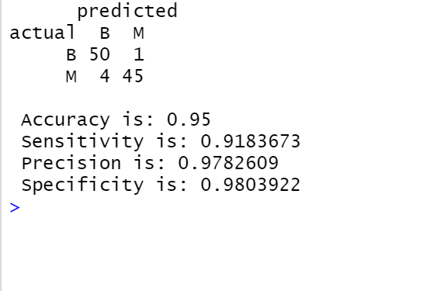

Conclusion:

The code written in R shows us the predicted and actual values in the form of a confusion matrix and also the measurements for the following is shown:

>Accuracy-0.95

>Sensitivity-0.9183673

>Precision-0.9782609

>Specificity-0.9803922

